LAB 8 TASKS

**TASK 01:**

**A local community center is organizing a workshop where participants will learn about matrix operations. As part of the workshop, you are tasked with creating a program that helps the participants understand how to compute the sums of the rows and columns of a matrix. Write a C program that allows users to input a 3x3 matrix representing the scores of three different activities completed by three participants in the workshop. After entering the matrix, the program should calculate and display:**

**1. The sum of each row, which indicates the total score of each participant across all activities.**

**2. The sum of each column, which reflects the total score for each activity across all participants.**

**SOURCE CODE:**

**#include<stdio.h>**

**int main()**

**{**

**int scores[3][3];**

**int i,j,k;**

**for(i=0;i<3;i++)**

**{**

**printf("ENTER 3 SCORES OF PARTICIPANT %d\n",i+1);**

**for(j=0;j<3;j++)**

**scanf("%d",&scores[i][j]);**

**}**

**printf("PARTICIPANT SCORES:\n");**

**for(i=0;i<3;i++)**

**{**

**for(j=0;j<3;j++)**

**printf("%d\t",scores[i][j]);**

**printf("\n");**

**}**

**for(i=0;i<3;i++)**

**{**

**int sum=0;**

**for(j=0;j<3;j++)**

**{**

**sum=sum+scores[i][j];**

**}**

**printf("SUM OF SCORE OF PARTICIPANT %d IS %d\n",i+1,sum);**

**}**

**for(i=0;i<3;i++)**

**{**

**int col_sum=0;**

**for(j=0;j<3;j++)**

**{**

**col_sum=col_sum+scores[j][i];**

**}**

**printf("SUM OF ACTIVITY %d IS %d\n",i+1,col_sum);**

**}}**

**OUTPUT:**

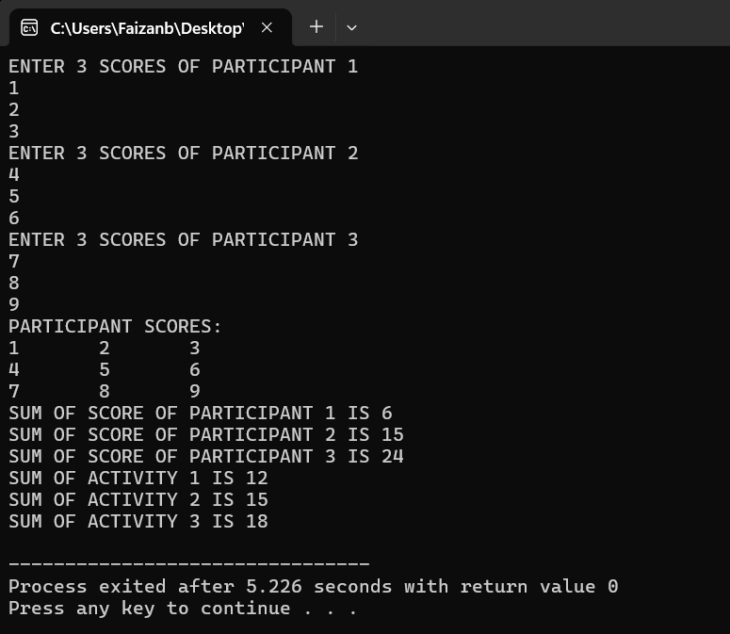

TASK 02:

A school is conducting an analysis of students’ grades in four different subjects. The grades are recorded in a 4x4 matrix, where each row represents a student and each column represents a subject. However, due to an error in data entry, some students received negative grades, which are not valid.

Write a C program that allows users to input a 4x4 matrix representing the grades of four students across four subjects. The program should replace all negative grades in the matrix with zero, ensuring that the data reflects valid scores. After processing the matrix, display the updated matrix with the correct grades.

SOURCE CODE:

**#include<stdio.h>**

**int main()**

**{**

**int std[4][4];**

**int i,j;**

**for(i=0;i<4;i++)**

**{**

**printf("ENTER THE MARKS OF STUDENT %d IN 4 SUBJECTS:\n",i+1);**

**for(j=0;j<4;j++)**

**{**

**scanf("%d",&std[i][j]);**

**}**

**}**

**printf("OLD GRADES\n");**

**for(i=0;i<4;i++)**

**{**

**for(j=0;j<4;j++)**

**printf("%d\t",std[i][j]);**

**printf("\n");**

**}**

**printf("UPDATE GRADES\n");**

**for(i=0;i<4;i++)**

**{**

**for(j=0;j<4;j++)**

**{**

**if(std[i][j]<0)**

**std[i][j]=0;**

**printf("%d\t",std[i][j]);**

**}**

**printf("\n");**

**}}**

OUTPUT:

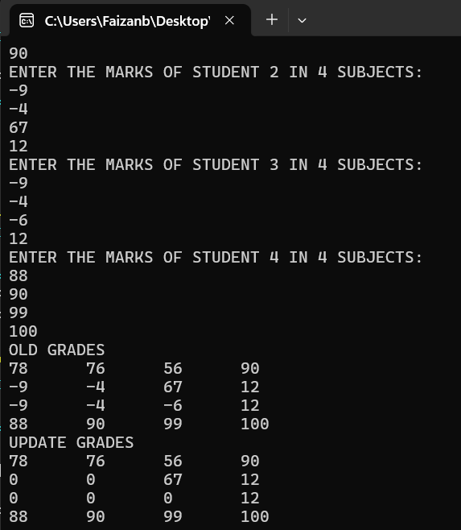

TASK 03:

Write a C program to print a number sandglass pattern for a given number of rows n.

SOURCE CODE:

#include<stdio.h>

int main()

{

int i,j,s,n;

printf("ENTER NO OF ROWS:");

scanf("%d",&n);

for(i=n;i>=1;i--)

{

for(s=i;s<=n;s++)

printf(" ");

for(j=i;j>=1;j--)

printf("%d ",j);

printf("\n");

}

for(i=2;i<=n;i++)

{

for(s=n;s>=i;s--)

printf(" ");

for(j=i;j>=1;j--)

printf("%d ",j);

printf("\n");

}

}

OUTPUT:

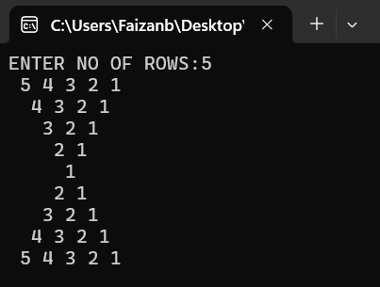

TASK 04:

A data analysis company is developing a tool to help researchers combine their findings from two different studies. Each study’s results are represented as matrices, where each matrix can have a size of m x n. The researchers need to add these matrices together to obtain a combined result. Write a C program that prompts users to enter the dimensions (m and n) for two matrices. Then, allow the users to input the elements of both matrices. The program should compute the sum of the two matrices and display the resulting matrix.

SOURCE CODE:

**#include<stdio.h>**

**int main()**

**{**

**int r2,c2,r1,c1;**

**printf("ENTER THE ROWS OF FIRST MATRIX:");**

**scanf("%d",&r1);**

**printf("ENTER THE COLUMNS OF FIRST MATRIX:");**

**scanf("%d",&c1);**

**printf("ENTER THE ROWS OF 2ND MATRIX:");**

**scanf("%d",&r2);**

**printf("ENTER THE ROWS OF 2ND MATRIX:");**

**scanf("%d",&c2);**

**if(r1!=r2 || c1!=c2)**

**{**

**printf("MATRIX CANNOT BE ADDED AS ORDER IS NOT SAME");**

**return 0;**

**}**

**int arr1[r1][c1];**

**int arr2[r2][c2];**

**int sum[r1][c1];**

**int i,j;**

**printf("ENTER ELEMENTS OF MATRIX 1:\n");**

**for(i=0;i<r1;i++)**

**{**

**for(j=0;j<c1;j++)**

**scanf("%d",&arr1[i][j]);**

**}**

**printf("MATRIX 1:\n");**

**for(i=0;i<r1;i++)**

**{**

**for(j=0;j<c1;j++)**

**printf("%d\t",arr1[i][j]);**

**printf("\n");**

**}**

**printf("ENTER ELEMENTS OF MATRIX 2:\n");**

**for(i=0;i<r2;i++)**

**{**

**for(j=0;j<c2;j++)**

**scanf("%d",&arr2[i][j]);**

**}**

**printf("MATRIX 2:\n");**

**for(i=0;i<r2;i++)**

**{**

**for(j=0;j<c2;j++)**

**printf("%d\t",arr2[i][j]);**

**printf("\n");**

**}**

**printf("ADDITION MATRIX:\n");**

**for(i=0;i<r1;i++)**

**{**

**for(j=0;j<c1;j++)**

**{**

**sum[i][j] = arr1[i][j]+arr2[i][j];**

**}**

**}**

**for(i=0;i<r2;i++)**

**{**

**for(j=0;j<c2;j++)**

**printf("%d\t",sum[i][j]);**

**printf("\n");**

**}**

**}**

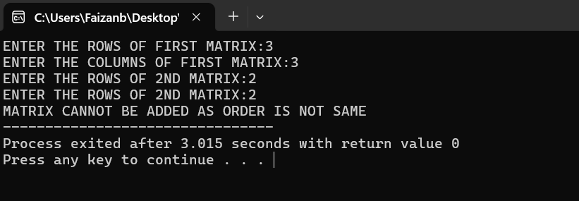

TASK 5:

A computer science club at a university is hosting a coding competition, and one of the challenges involves working with matrices. Participants are required to demonstrate their ability to manipulate matrices effectively. Write a C program that allows users to input a 4x4 matrix representing the scores of three different teams across three rounds of a competition. The program should then rearrange the elements of each column in ascending order to reflect the teams’ performance in each round.

**SOURCE CODE:**

#include<stdio.h>

int main()

{

int scores[4][4];

int i,j,k,t;

for(i=0;i<4;i++)

{

printf("ENTER THE SCORES OF TEAM %d IN ROUND %d\n",i+1,i+1);

for(j=0;j<4;j++)

scanf("%d",&scores[i][j]);

}

printf("\tMATRIX:\n");

for(i=0;i<4;i++)

{

for(j=0;j<4;j++)

printf("%d\t",scores[i][j]);

printf("\n");

}

printf("MATRIX COLUMNS IN ASCENDING ORDER ARE:\n");

for(j=0;j<4;j++)

{

for(i=0;i<4;i++)

{

for(k=i+1;k<4;k++)

{

if(scores[i][j]>scores[k][j])

{

t=scores[i][j];

scores[i][j]=scores[k][j];

scores[k][j]=t;

}

}

}}

for(i=0;i<4;i++)

{

for(j=0;j<4;j++)

printf("%d\t",scores[i][j]);

printf("\n");

}

}

OUTPUT:

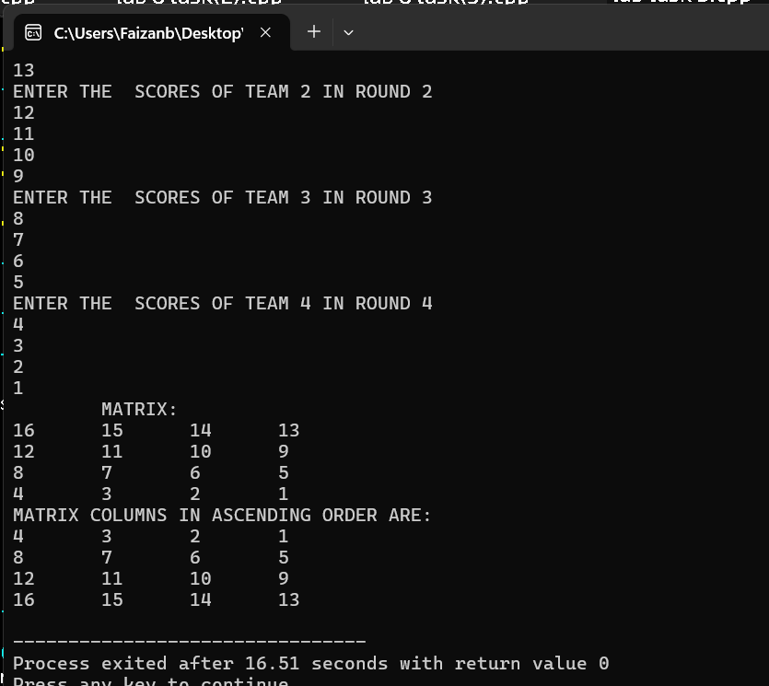

TASK 06:

Write a C program to print a hollow square with diagonals for a given side length.

SOURCE CODE:

#include<stdio.h>

int main()

{

int i,j,n;

printf("ENTER SIDE LENGTH:");

scanf("%d",&n);

if(n%2==0)

{

printf("INVALID ROW NUMBER");

return 0;

}

for(i=1;i<=n;i++)

{

for(j=1;j<=n;j++)

{

if(i==1 || j==1 || i==n ||j==n || i==j || j==(n-i+1))

printf("*");

else

printf(" ");

}

printf("\n");

}

}

OUTPUT

